Choosing a Bicycle Wheel

Abstract
To make a decision between the spoked wheels and the disk wheels is to find a delicate balancing point between the effort needed to overcome the effect the effect of the extra weight of a disk rear wheel on performance and aerodynamic efficiency.
On a flat road, wind resistance and wheel drag are by far the greatest barrier to a cyclist's speed. The only greater obstacle is climbing up a hill: the higher a road grade is, the more effort is needed to pedal a bike uphill against the force of gravity. We first develop a simple model to find the wind speed at which the power required for a solid rear wheel is less than for a spoked rear wheel at an given road grade to remain a constant velocity. After some further researches, we develop a more accurate method for evaluating and estimating cycling performance of different types of rear wheel using ordinary differential equations. This model allows a changing-with-time velocity of rider
In the end we mention some other details that could also make a big difference in deciding on the wheel configuration.
The analysis of the problem
Disk wheel
A wheel with an integral smooth cover from the rim to the hub than reduces wheel trag. Introduced as early as 1878 by Otton & Wallis in England, but pioneered in modern times by Italy's Ambrosio for Francesco Moser's hour record attempt in 1984.
Disk wheels may be made of a solid plastic or composite material or have a light weight framework such as a web matrix or honeycomb with an integral cover. A disk wheel is noisy, expensive, heavy, and creates a rough ride because there are no spokes to flex. Standard wheels with wheel covers are not as speedy as disk wheels, but they smoother riding, quieter, and cheaper.

Wind Resistance
It's exhausting for cyclists to pedal even when it is windless. Because in order to move forward the cyclist must push through the mass of air in front of him. This takes energy.
Wind resistance is composed of two forces: air pressure drag and direct friction (also known as surface friction or skin friction).
Air pressure drag: as a cyclist is riding ahead the rider and the bicycle disturb the air flowing around them, forcing the air to separate from their surface. Low pressure regions from behind them result in a pressure drag against them. So with high pressure in the front, and low pressure behind, the cyclist is literally being pulled backwards. Though the human body is simply not well designed to slice through the air, streamlined designs cuts through the air more smoothly around the body and reduce pressure drag, enabling a cyclist to travel much faster with less effort.
Direct friction: when wind comes into contact with the outer surface of the rider and the bicycle the direct friction occurs. Racing cyclists often wear "skinsuits" in order to reduce direct friction.
Then the magnitude of wind resistance is:
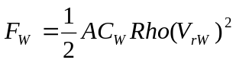
Where
 is the effective frontal area of bike and rider.
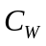 is the drag coefficient
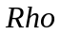 is the air density.
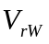 is the relative velocity of the rider and the wind.

Rolling Resistance
Rolling resistance is the force in Newtons on the rider and bike caused by the rolling friction on the road, which can be represented by
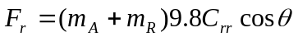
Where
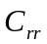 is the coefficient of rolling resistance
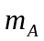 is the weight of bike, rider and front wheel
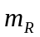 is the weight of the rear wheel

Gravity Forces
Gravity forces pull the rider and bike down the hill. The road grade is defined here to be the ratio of the total rise of a hill divided by the length of the road. The gravity forces is
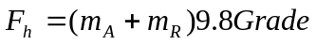

Wheel drag
From a paper by D. I. Greenwell, et. al., entitled "Aerodynamic Characteristics of Low-Drag Bicycle Wheels", Aeronautical J., Vol. 99, No. 983, Mar. 1995, pp.109-120, we can get the following information about aerodynamics of bicycle wheels:
- Among the total drag on a bike the total drag of the wheels is in the range of 10% to 15%. If drag improvements between wheels can reduce this by 25%, that will account for 2% to 3% of the total drag.
- It is not easy to make a precise measurement of axial drag forces so most single valued measurements should be suspect.
- Disk wheels are better than a conventional 36 spoke wheel but one should not run a disk in front if there is any chance of wind.)
- The rotational drag on a wheel does not change as speed changes or with different wheels.
The axial force on a wheel can be represented as
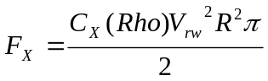

Where
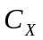 is the axial force drag coefficient at zero wind yaw angle
is the air density
is the relative velocity of the rider and wind
 is the radium of the wheel

Power
Power, 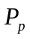, is the work required per unit of time to overcome the net forces acting on the rider, bike and wheel.

Initial Assumptions
- Our models do not take into account the body position (or size) of the rider in regard to wind resistance. The effective frontal area of rider is typically between 0.4 m² and 0.7 m² [www.cyclingsino.net]. A large rider may have a larger frontal area. In our model we choose 0.5 m²
- The velocity of the wind is constant and is at zero yaw angle.
- The drag coefficient is fixed at 0.5.
- The axial force drag coefficient is at zero wind yaw angle.
- The air density is from Temperature, Barometric Pressure, and altitude, which is
Sea Level 1.226 kg/m³
1500 Meters 1.056 kg/m³
3000 Meters 0.905 kg/m³
[www.analyticcycling.com].
In our models we use 1.226 kg/m³, but it can be changed in different conditions.
- The coefficient of rolling resistance is available as following:
Wooden Track 0.001,
Smooth Concrete 0.002,
Asphalt Road 0.004,
Rough but Paved Road 0.008
[www.analyticcycling.com]
In our models we use 0.004, but it can be changed in different conditions.
- The human body is 100 percent efficient--this is not the case (20 percent efficiency is closer) --and we use the typical power of 300w.
- We use the standard 32 spoke wheel as an example of the spoke wheel and it can be described as: axial force drag coefficient at zero wind yaw angle 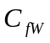=0.0491, weight m=1.264kg, radium =0.337m, while the disk wheel is characterised as: 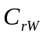=0.035, m=1.464kg =0.337m.
- We assume that the weight of the rider is 65kg and the weight of the bike without wheels is 8kg.

The Constant Velocity Model
The constant velocity model is based on the assumption that the velocity of the rider and wind in the long climb remains constant. The relative velocity of rider and wind 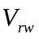 equals the velocity of wind 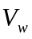 plus that of rider 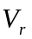.
From the equations:
Wind Resistance 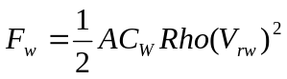
Rolling Resistance
Gravity Forces 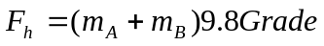
Front wheel drag 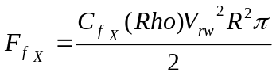
Rear wheel drag 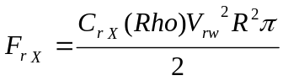

Power 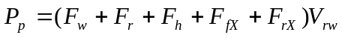
Applying the data we have mentioned in the initial assumption, we create the following table and plot giving the relative velocity of rider and wind at which the power required for a disk rear wheel equals that for a spoked rear wheel:

grade | 0 | 0.01 | 0.02 | 0.03 | 0.04 | 0.05 | 0.06 | 0.07 | 0.08 | 0.09 | 0.1
V(m/s) | 1.5903 | 2.9752 | 3.8954 | 4.6352 | 5.2744 | 5.8431 | 6.3612 | 6.8041 | 7.2876 | 7.7092 | 8.1089
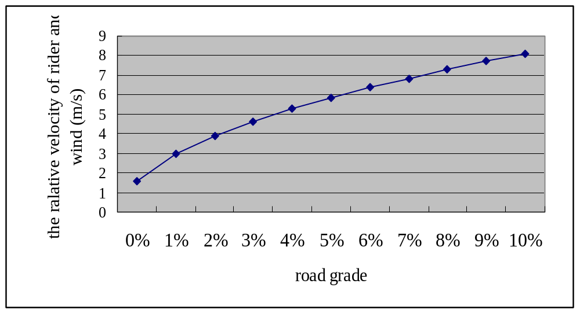
If the relative velocity of rider and wind is below the point in the plot for a given grade, we recommend a spoked rear wheel. Otherwise a disk rear wheel gives a better performance.
Differential Equations Model
Wheel Rotational Inertia
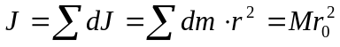The rotational inertia of the wheel can be calculated as
Where
is the distance from the center of gravity of the wheel to a particle in the wheel.
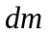 is the mass of the particle
 is the mass of the wheel

Differential Equations
From fundamental physics:
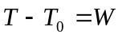
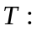 the kinetic energy of the system at time t
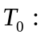 the kinetic energy of the system at time t₀ ( Here it is a constant.)
 the net work acting on the system

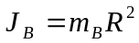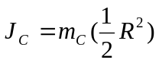

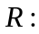 the radium of the wheel
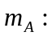 the weight of bike, rider and front wheel
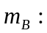 the weight of the spoked wheel
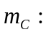 the weight of the disk wheel minus that of the spoked wheel
v : the velocity of rider, a function of time
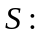 the distance from the start point , a function of time
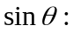 the grade of the hill
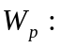 the work of the rider
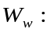 the work required to over come the wind resistance against rider and bike
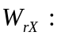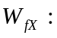 the work required to over come the drag of rear wheel
the work required to over come the drag of front wheel
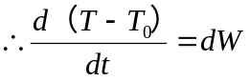
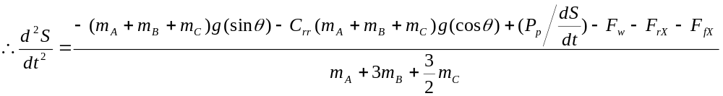 (1)
and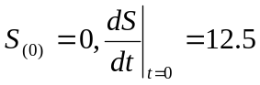 (2)
Note: 12.5mps (45kph) comes from the problem.
: the velocity of wind
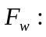 the magnitude of wind resistance
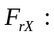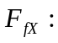 the axial force on front wheel
the axial force on rear wheel
From equations (1) and (2) we get:
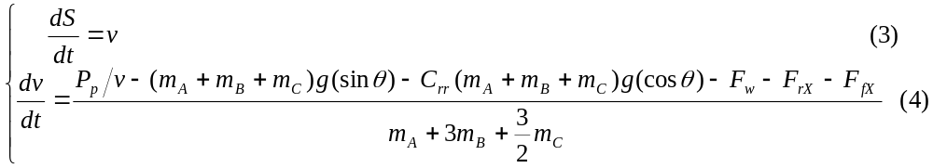
and 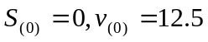 (5)
Equations (3) and (4) satisfy Lipschiz conditions, so equations (3), (4) and (5) have unique solution. As equations (1) and (2) are equivalent to equations (3),(4) and(5), they also have unique solutions.
Using Runge-Kutta Method and Matlab, we apply the data mentioned in the initial assumption to compare the performance of different types of wheels.
The following table gives the wind speed above which the power required for a disk rear wheel is less than that for a spoked rear wheel (we :

grade | 0.00 | 0.01 | 0.02 | 0.03 | 0.04 | 0.05 | 0.06 | 0.07 | 0.08 | 0.09 | 0.10
wind speed  (m/s) | 0 | 0 | 0 | 0 | 0 | 1.0 | 2.5 | 3.8 | 4.5 | 5.5 | 6.3

To demonstrate how the table could be used for a specific time trial course, we give four typical plots for (a five percent grade, 0mps wind velocity), (a five percent grade, 2mps wind velocity), (a ten percent grade, 5mps wind velocity) and (a ten percent grade, 8mps wind velocity) respectively. Each plot shows during a certain time the distance a rider can go. Such data for other grade and wind velocity can be easily obtained using our model.
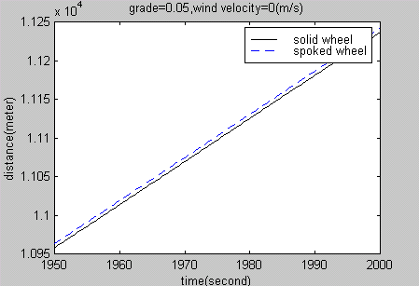
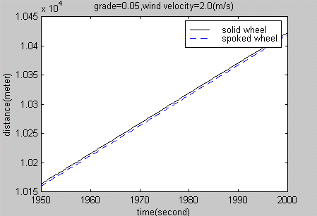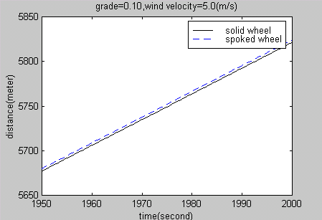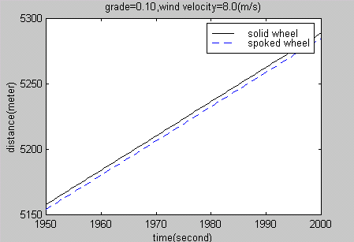
Conclusions :
- The higher a road grade is, the more effort is needed to pedal a bike uphill against the force of gravity. The faster the wind velocity is, the more wind resistance and wheel drag they experience and the more energy they must exert to overcome them.
- For a given relative velocity of wind and rider, the negative effect of the extra weight of a disk rear wheel on performance is in positive proportional to the road grade.
- For a given road grade, the advantage of a disk rear wheel in terms of drag force is in positive proportional to the relative velocity of wind and rider. So a disk rear wheel can’t have meaningful aerodynamic benefits for a slow speed.

Other Considerations

Wind and Courses
In reality, the wind can come from any direction and its speed can be changing with time. If there is a relative wind angle (the direction of wind experienced by the rider and bike), the side force drag should be measured. The lower the side force, the less effect a crosswind has on bicycle handling. Road courses also change direction and go up and down hills. In that case a course can be described by a series of course segments. Each segment has a distance, direction( the compass direction in which the rider is heading), slope, coefficient of rolling resistance, prevailing wind direction(the compass direction from which the wind is blowing), wind speed, and wind variability(an amount by which the wind speed increases or decreases randomly over time). Thus a more considerable decision should be based on certain data of different courses.

Costs
Cost is also an important consideration in a sport that places great stress on equipment. As disk wheels usually cost more than the standard spoked wheels, few non-sponsored riders may prefer the cheaper ones.

Strengths and Weaknesses
Our models are flexible in that they can present performance data in the form of plots and tables of different wheels for a range of conditions including road grade, wind velocity, the ground, air density and effective frontal area. Thus we can satisfy the need of the director sportif.
Our models assume that the wind is constant and is at zero yaw angle, but in fact it can be fluctuating and coming at any angle. That is the weakness of our models. However we give some analysis in the part of other considerations.
References:
William F. LUCAS 1998. Modules in Applied Mathematics. Vol. 1: Differential Equation Models. Changsha: National University of Defence Technology Press.
YuanZhenDong ect. 1997. Modelling in Mathematics(in Chinese). Shanghai: ECNUP.
----------. 2000. Wind on Rider.
http://www.analyticcycling.com/DiffEqwindCource _page.html
---------. 2000. Performance and Wheels Concepts .
http://www.analyticcycling.com/wheelsconcept_Disc.html
---------. ----. Air Ressistance
http://www.cyclingsino.net/cheyou/yundongzhishi/lilun3.htm

